

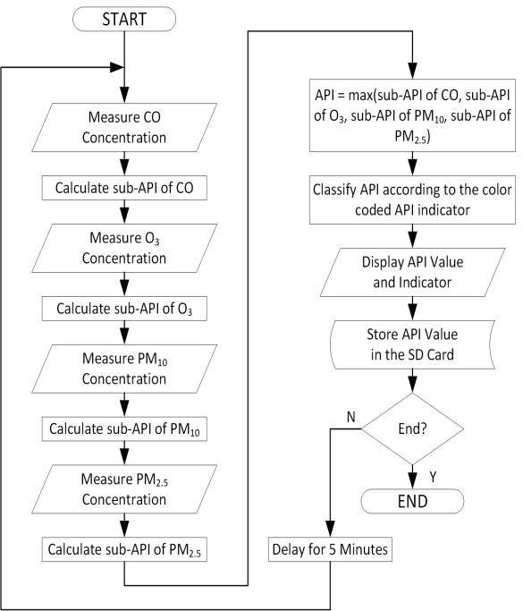

**The use of multi-parameter air quality monitoring systems makes it possible to do a detailed level analysis of major pollutants and their sources.**

**These monitoring systems are important components in many smart city projects for monitoring air quality and for controlling the main pollutant concentrations in urban areas.**

**WATER MANAGEMENT**

**During the past decade, water needs have increased unpredictably in India. Increasing demand of water supply has become a major challenge for the world. Wasteful usage of water, climatic changes and Urbanization has further depleted the resource. Conservation and management of the resource must be given utmost importance. In this paper, we present an IoT design for water monitoring and control approach which supports internet based data collection on real time bases. The system addresses new challenges in the water sector -flow rate measuring and the need for a study of the supply of water inorder to curb water wastage and encourage its conservation. We also measure the quality of water distributed to every household by deploying pH and conductivity sensors. The traditional water metering systems require periodic human**

**intervention for maintenance making it inconvenient and often least effective.For shortcoming of the existing models for a ubiquitous usage of wireless systems for smart quality monitoring and communicate data wirelessly.**

**FLOWCHART FOR SMART WATER MANAGEMENT:**

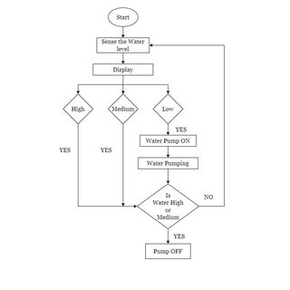

insert lage ENVIRONMENTAL MONITORING TOOL



|  |  |  |  |
| --- | --- | --- | --- |
| Country | Date | Location | Waste |
| Ghana | 1-Jan-19 | Head Office | Engine Oil |
| Ghana | 3-Feb-19 | Head Office | Fuel Filters |
| Ghana | 4-Mar-19 | Head Office | Air Filters |
| Ghana | 5-Apr-19 | Head Office | Air Filters |
| Ghana | 6-May-19 | Head Office | Insecticide |
| Ghana | 7-Jun-19 | Regional Offices | Insecticide |
| Ghana | 8-Jul-19 | Head Office | Herbiodes |
| Ghana | 9-Aug-19 | Regional Offices | Oil filters |
| Ghana | 10-Sep-19 | Regional Offices | Insecticide |
| Ghana | 11-Oct-19 | Head Office | Engine Oil |
| Ghana | 12-Nov-19 | Head Office | Fuel Filters |
| Ghana | 13-Dec-19 | Head Office | Insecticide |
| Insecticide | | | |
|  | | | |

REDUCE REUSE RECYCLE



|  |  |  |
| --- | --- | --- |
| Quantity Generated(kg) | Quantity Reused(kg) | Quantity Recycled(kg) |
| 300 | 300 | |
| 150 | 150 | |
| 230 | 230 | |
| 30 | 30 | |
| 30 | 30 | |
| 150 | 150 | |
| 230 | 230 | |
| 30 | 30 | |
| 30 | 30 | |
| 30 | 30 | |
| 30 | 30 | |
| 150 | 150 | |
| 100 | 100 | |

|  |  |
| --- | --- |
| Quantity Remains(kg) | Hazardous Solid Waste(m3) |
| 0 | |
| 0 | |
| 0 | |
| 0 0.03 | |
| 0 | |
| 0 | |
| 0 | |
| 0 0.03 | |
| 0 | |
| 0 | |
| 0 | |
| 0 0.15 | |
| 0 | |













SENSOR OUTPUT:

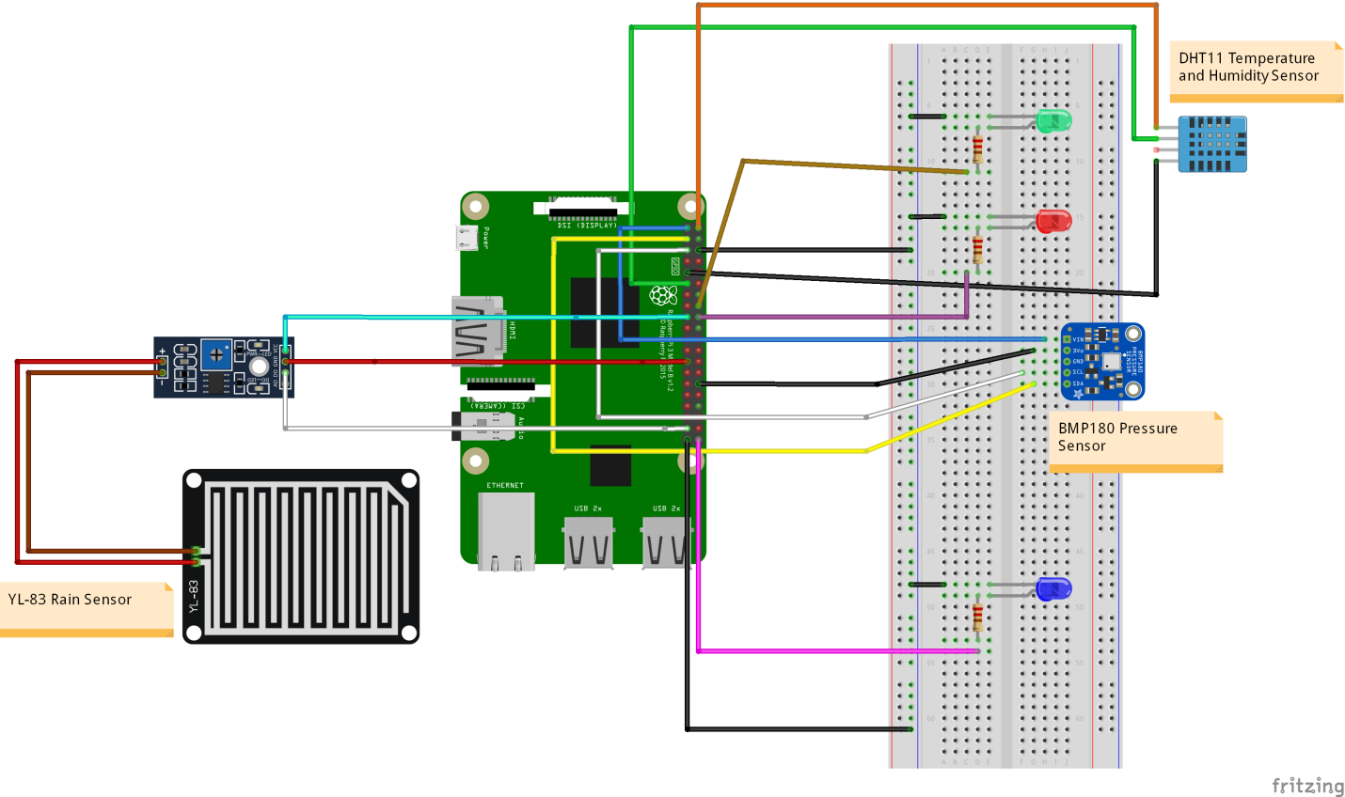

**Output:**

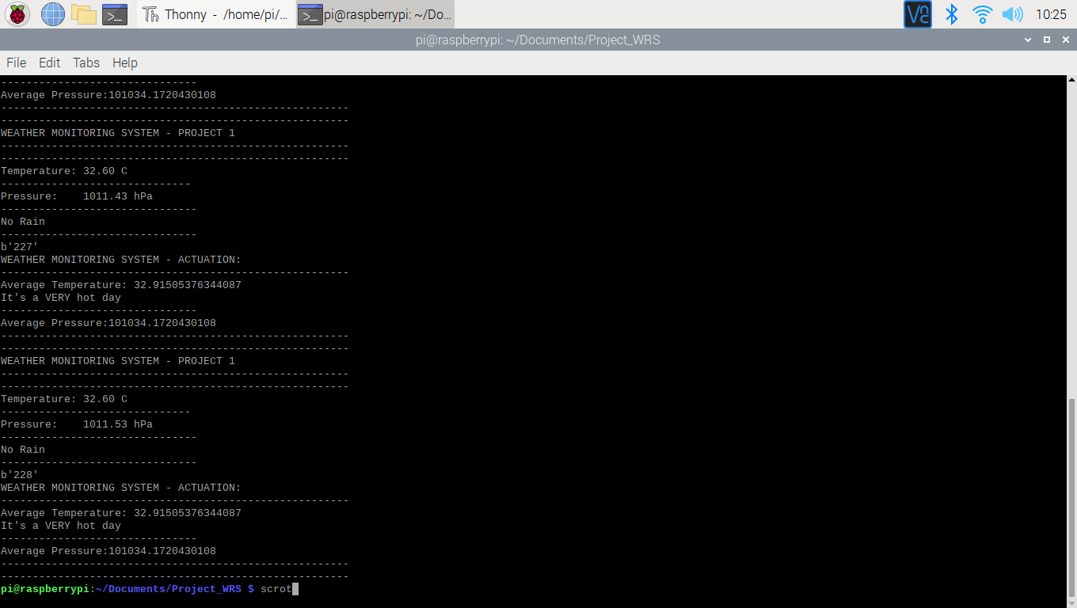

**HTML:**

<!DOCTYPE html>

<html>

<head>

<title>BMP180 Sensor Data</title>

</head>

<body>

<h1>BMP180 Sensor Data</h1>

<p>Temperature: <span id="temperature">Loading...</span> &deg;C</p>

<p>Pressure: <span id="pressure">Loading...</span> Pa</p>

<p>Altitude: <span id="altitude">Loading...</span> meters</p>

<script>

// Function to update sensor data

function updateSensorData() {

// You may need to modify this URL to point to the location of your BMP180 sensor data

fetch('/get_sensor_data') // Replace with the actual URL or route for your data

.then(response => response.json())

.then(data => {

document.getElementById('temperature').textContent = data.temperature + ' &deg;C';

document.getElementById('pressure').textContent = data.pressure + ' Pa';

document.getElementById('altitude').textContent = data.altitude + ' meters';

})

.catch(error => {

console.error('Error fetching sensor data:', error);

});

}

// Call the function initially

updateSensorData();

// Set up periodic data update (e.g., every 5 seconds)

setInterval(updateSensorData, 5000); // Update every 5 seconds

</script>

</body>

</html>

What Are IoT Devices? Definition, Types, and 5 Most Popular for 2023

By Nikita Duggal

Last updated on Aug 7, 2023180841

What are IoT Devices : Definition, Types, and 5 Most Popular Ones for 2023

Table of Contents

What is IoT?Types of IoTWhy is IoT Important?What Are IoT Devices?How do IoT Devices Work?View More

The term “Internet of Things” or IoT was first coined by Kevin Ashton in 1999. But it was only when Gartner added IoT to its list of new emerging technologies in 2011, that it started to gain global momentum. As of 2021, there were 21.7 billion active connected devices in the world today, out of which more than 11.7 billion (54 percent) are IoT devices. This means that there are more IoT devices in the world than there are non-IoT devices.

Have a look at the video below that will help you understand IoT and how it works.

What is IoT?

IoT is an umbrella term that refers to the billions of physical objects or “things” connected to the Internet, all collecting and exchanging data with other devices and systems over the Internet.

While IoT has been in existence since the 90s, recent advances in a number of different technologies have made it more practical, such as:

Access to affordable and reliable sensors

Increase in the availability of cloud computing platforms

Advances in machine learning and AI technologies.

IoT devices can range from small ordinary household cooking appliances to sophisticated industrial tools. Each IoT component has a Unique Identifier (UID) and they can also transmit data without the assistance of humans.

**BLOCK DIAGRAM FOR IOT DEVICE:**



Types of IoT

The networking, communication and connectivity protocols depend largely on the specific IoT application deployed. Just as there are many different IoT devices, there are many types of IoT applications based on their usage. Here are some of the most common ones:

Consumer IoT - Primarily for everyday use. Eg: home appliances, voice assistance, and light fixtures.

Commercial IoT - Primarily used in the healthcare and transport industries. Eg: smart pacemakers and monitoring systems.